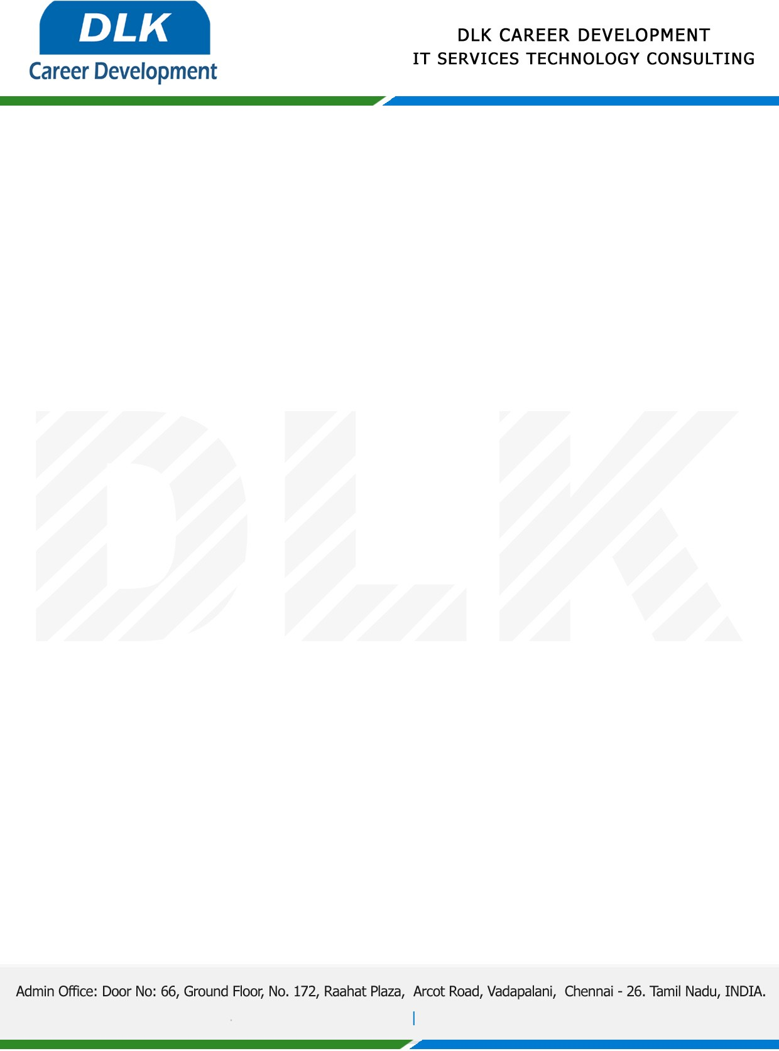

Date: 01/ December/ 2022

**To**

Department of [M.SC](http://M.SC) ([Computer Science),](https://www.cseindia.org/)

Head of Department,

SRI SANKARA ARTS AND SCIENCE COLLEGE.

**Sub: Letter of Project Acceptance**

This is to certify that **MR MUTHUKUMARAN D (REG NO: 2101212078009)** that final year student of has accepted his Project Work duration from **02 December 2022 to 09 March 2023** under the domain **“Python”.** During the internship, all information and data collected from you should be kept confidential.

**Topic:** **File Transfer System to Transfer Text from One Place to another Using Python**

We appreciate your interest in **DLK CAREER DEVELOPMENT**

